Unit 6.4 : Air Pressure
Topic : Magic water glass trick
Worksheet 2
Name : ______________
Class : ___________( )
Date : _______________
Task 2: How could we strop water flowing out from a bottle?

You are given a plastic bottle with a nail hole at the bottom.
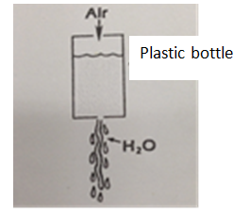

Procedure
- Use a tape to seal the nail hole.
- Fill the bottle with water.
- Discuss with group members. Suggest a method to stop water flowing out from the bottle if the tape is removed.
Use a tape to cover the mouth of the bottle or clos the bottle month with its cap.

- Explain why the water stops flowing out from the bottle by closing its month with the cap.

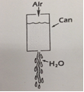
Plastic bottle

If we close the bottle month with its cap, the air pressure on the water from the month diminishes. Thus, the water only experiences air pressure from the nail hole. The air pressure exerts a force upwards to stop the water flowing out.

